Truncated Pentagonal Prism

Definition
# Source: AI Source: Provided by: [Data Path: Persons Table -> ID Column: 1, Name_En Column: Motasem Essam] -> From: [ChatGPT] on [7/25/2026]
A Truncated Pentagonal Prism is a solid derived from a pentagonal prism by cutting off one or more portions of the prism using planes.
The resulting shape depends on the number, position, and orientation of the cutting planes.
There are different possible constructions, so the term does not describe one uniquely defined polyhedron with fixed face, edge, and vertex counts.
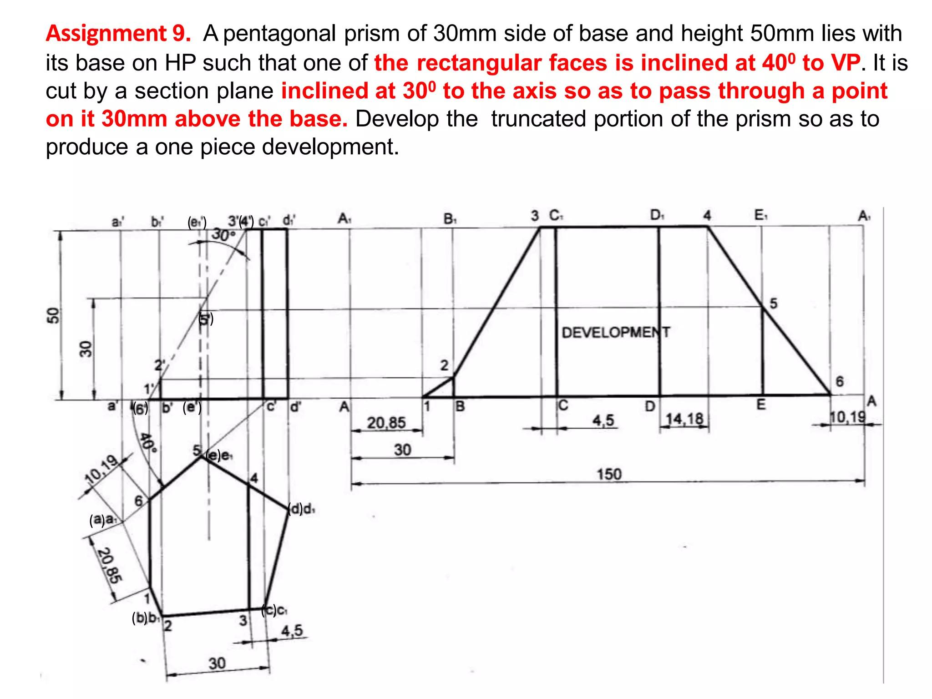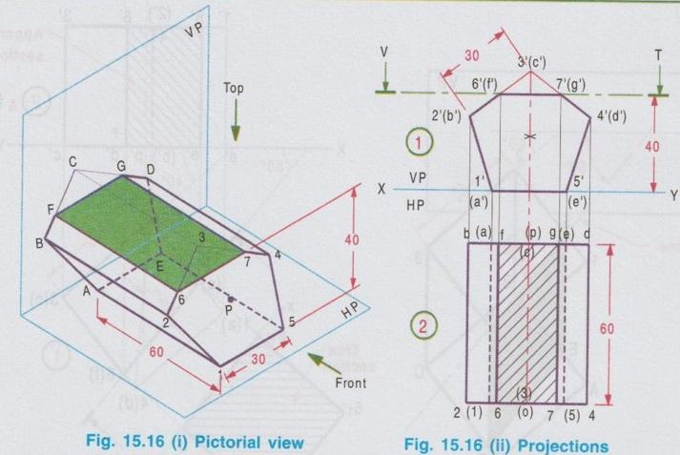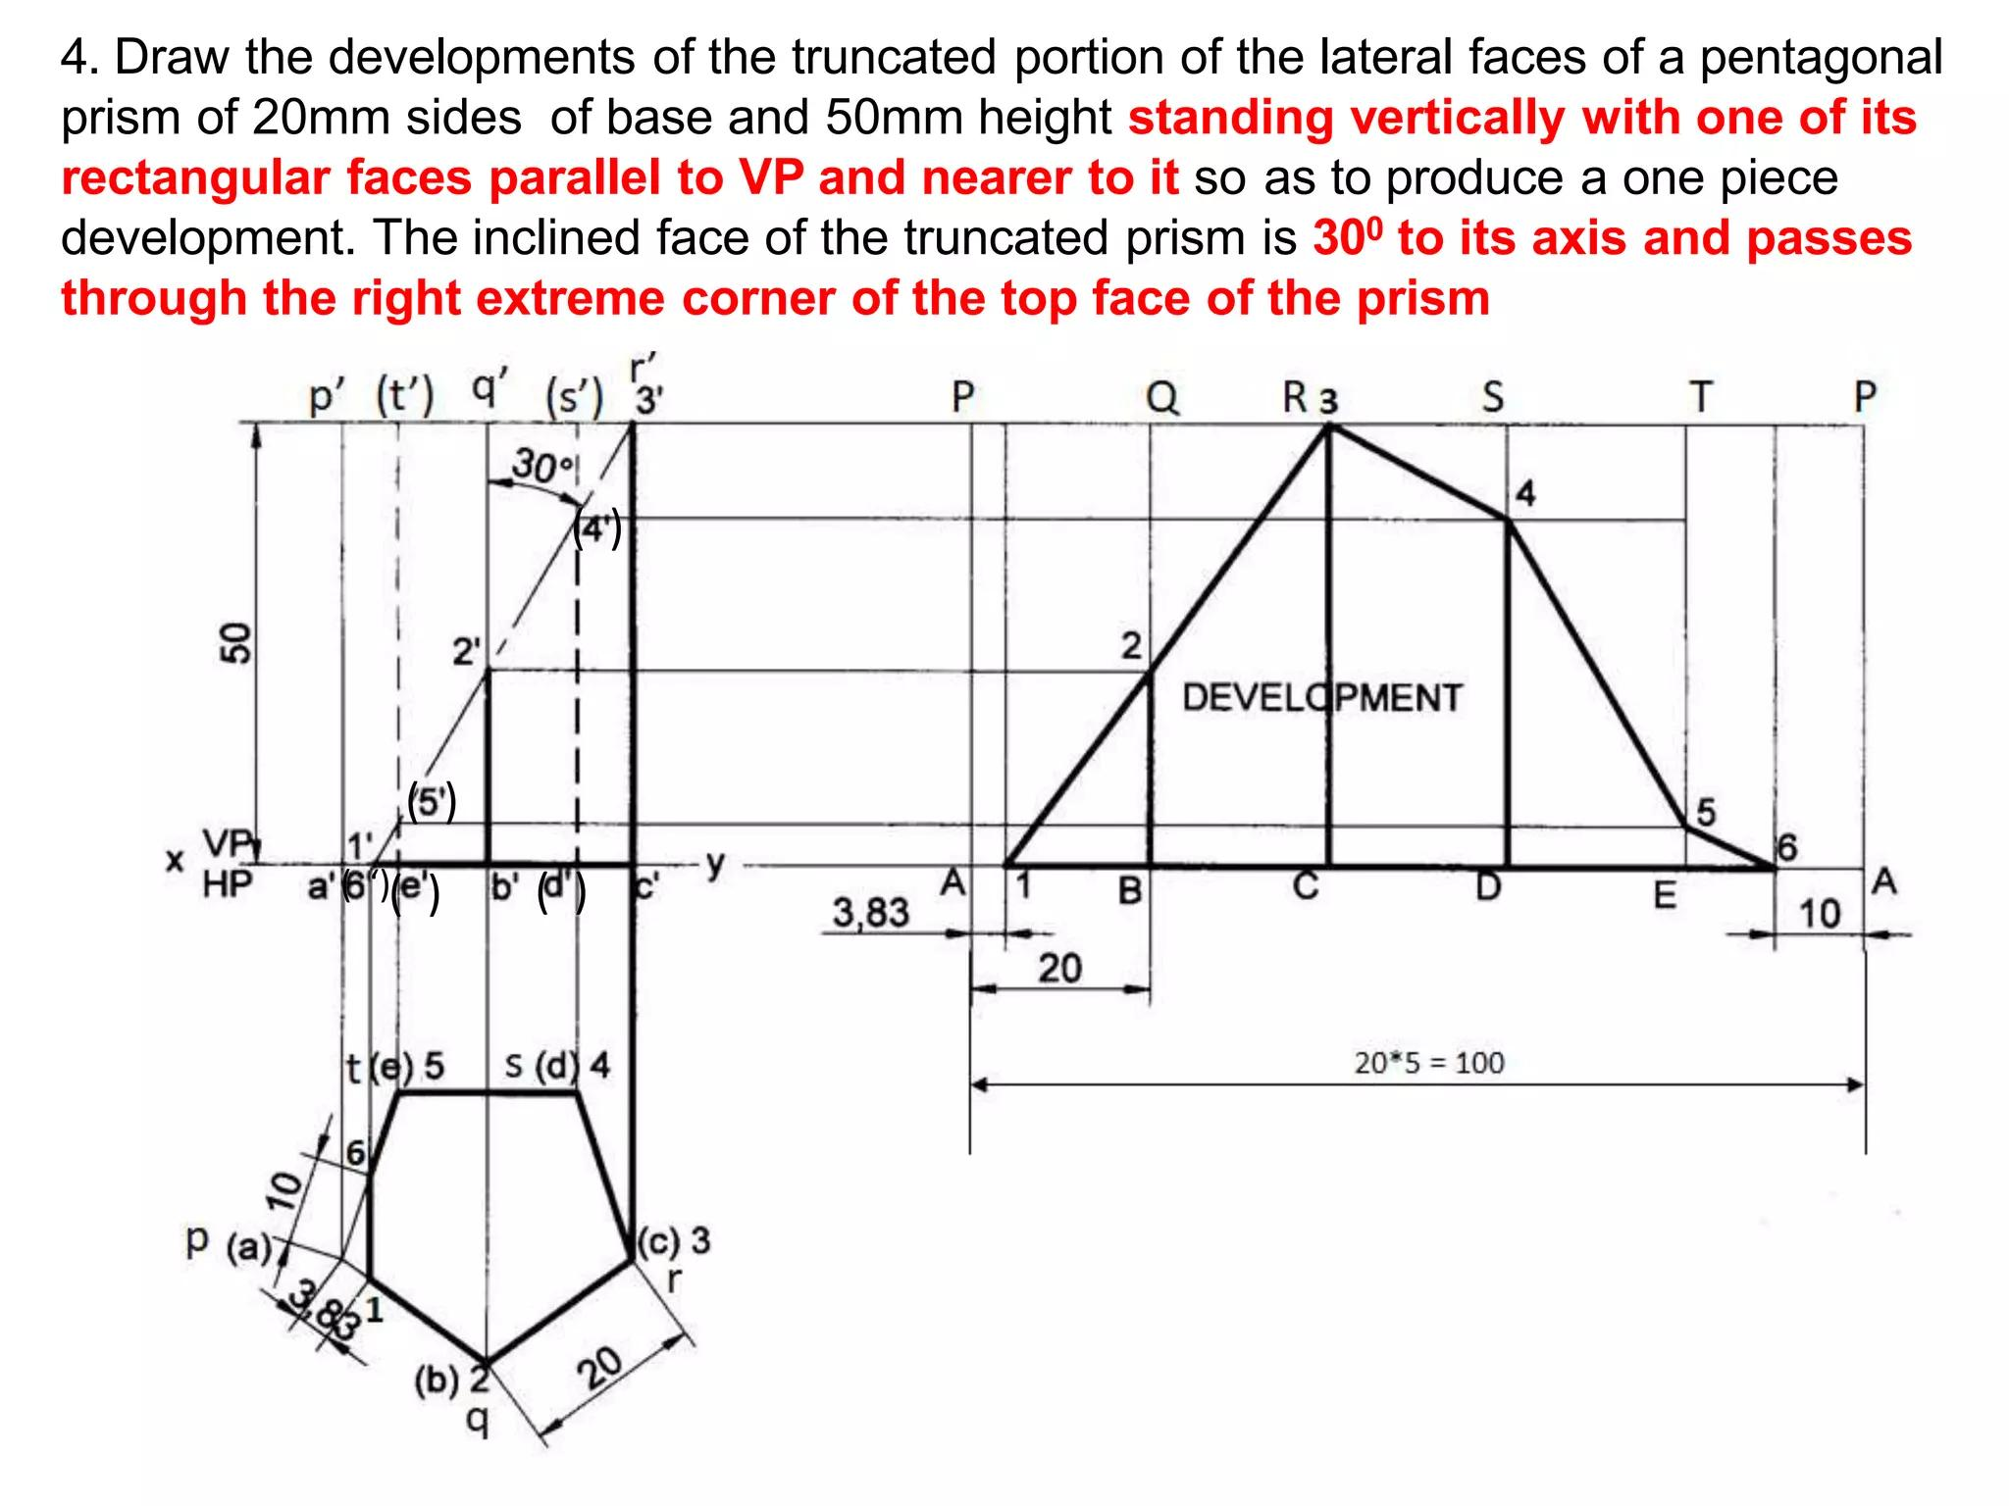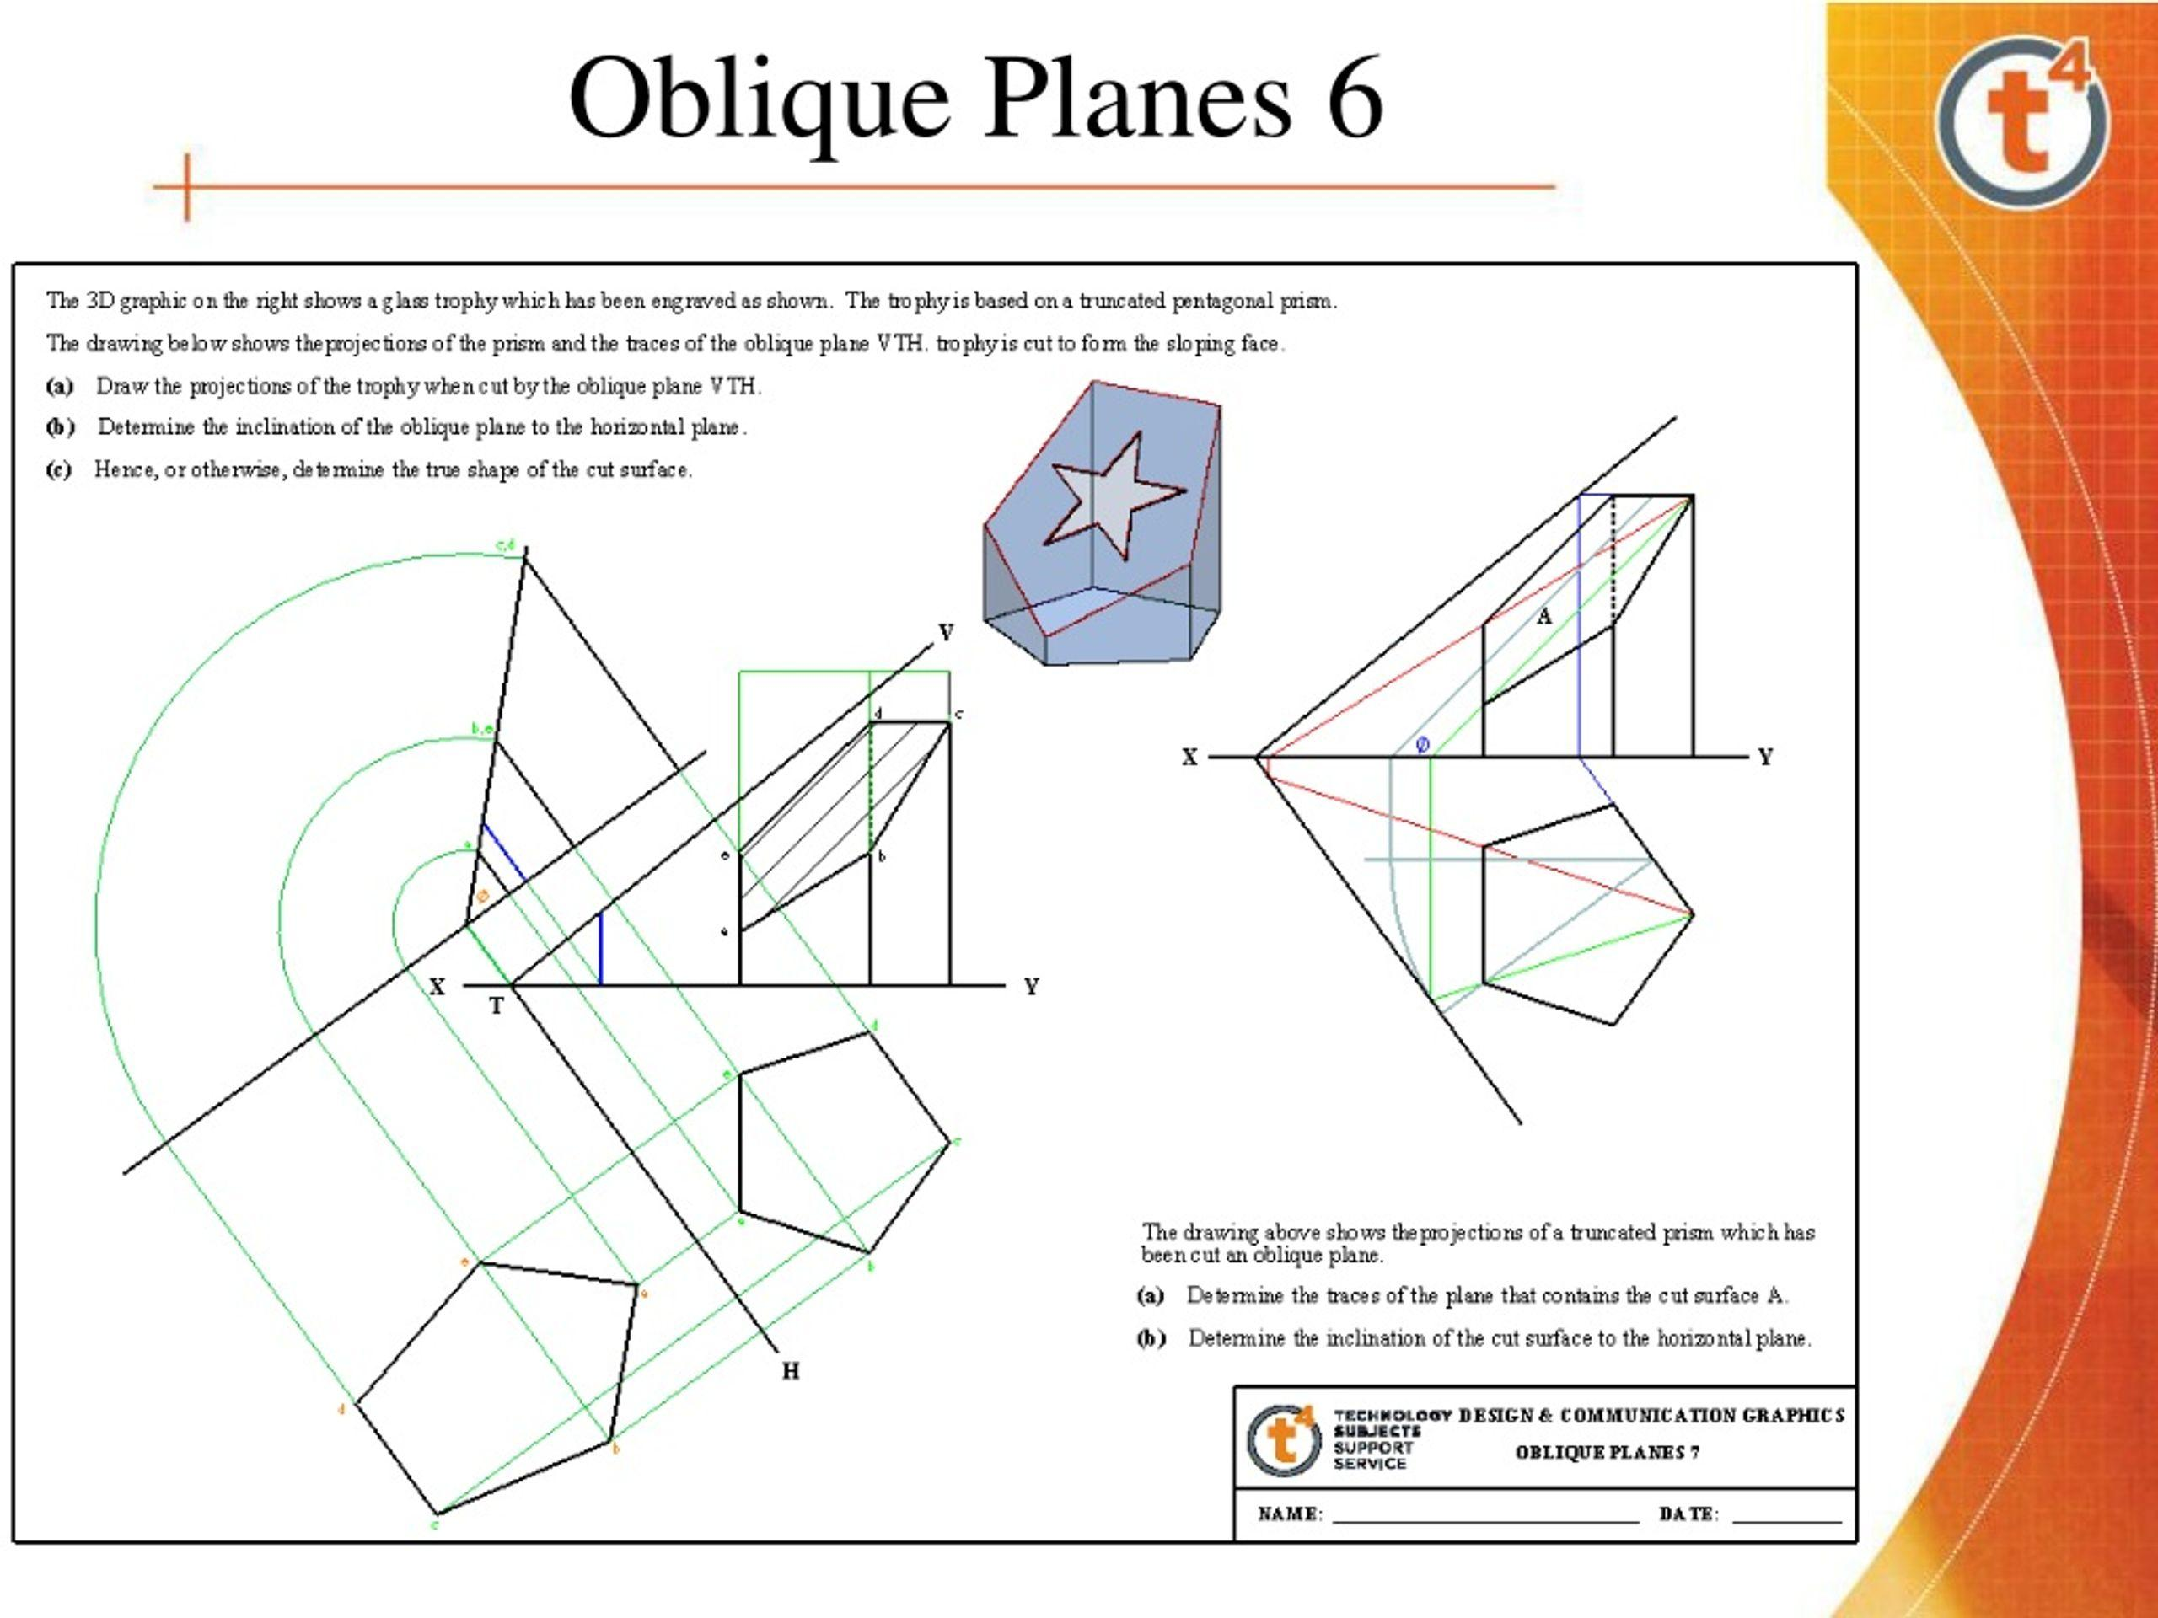

Geometric Structure
# Source: AI Source: Provided by: [Data Path: Persons Table -> ID Column: 1, Name_En Column: Motasem Essam] -> From: [ChatGPT] on [7/25/2026]
A regular pentagonal prism consists of:
- 2 pentagonal bases — top and bottom.
- 5 rectangular lateral faces — connecting the two bases.
- 10 vertices.
- 15 edges.
When it is truncated, the cutting plane or planes create new faces and modify the original faces.
Common cutting arrangements include:
- Single inclined cut: One inclined plane cuts through the prism.
- Parallel cuts: Two or more parallel planes remove portions of the prism.
- Vertex truncation: The corners of the prism are cut off.
- Multiple truncations: Several portions are removed from different locations.

Face Composition
# Source: AI Source: Provided by: [Data Path: Persons Table -> ID Column: 1, Name_En Column: Motasem Essam] -> From: [ChatGPT] on [7/25/2026]
The face composition depends on the truncation method.
For example, a pentagonal prism cut by a single plane that intersects all five lateral faces and does not intersect either base produces:
- 2 pentagonal bases.
- 5 lateral faces, each modified by the cut.
- 1 new cutting face.
The exact shapes of the modified lateral faces depend on the cutting plane.

Mathematical Properties
# Source: AI Source: Provided by: [Data Path: Persons Table -> ID Column: 1, Name_En Column: Motasem Essam] -> From: [ChatGPT] on [7/25/2026]
For the original pentagonal prism:
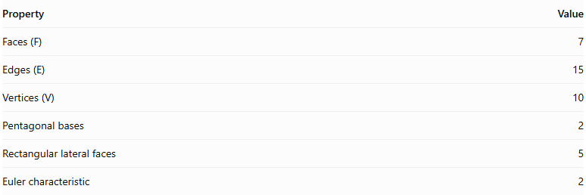
Property | Value
Faces (F) | 7
Edges (E) | 15
Vertices (V) | 10
Pentagonal bases | 2
Rectangular lateral faces | 5
Euler characteristic | 2
For a truncated version, the values depend on the cutting arrangement.
Euler's Formula
$$V-E+F=2$$
This formula applies to any convex, closed polyhedron, including a truncated pentagonal prism.

Constructing a Truncated Pentagonal Prism

Geometric Instruments
# Source: AI Source: Provided by: [Data Path: Persons Table -> ID Column: 1, Name_En Column: Motasem Essam] -> From: [ChatGPT] on [7/25/2026]
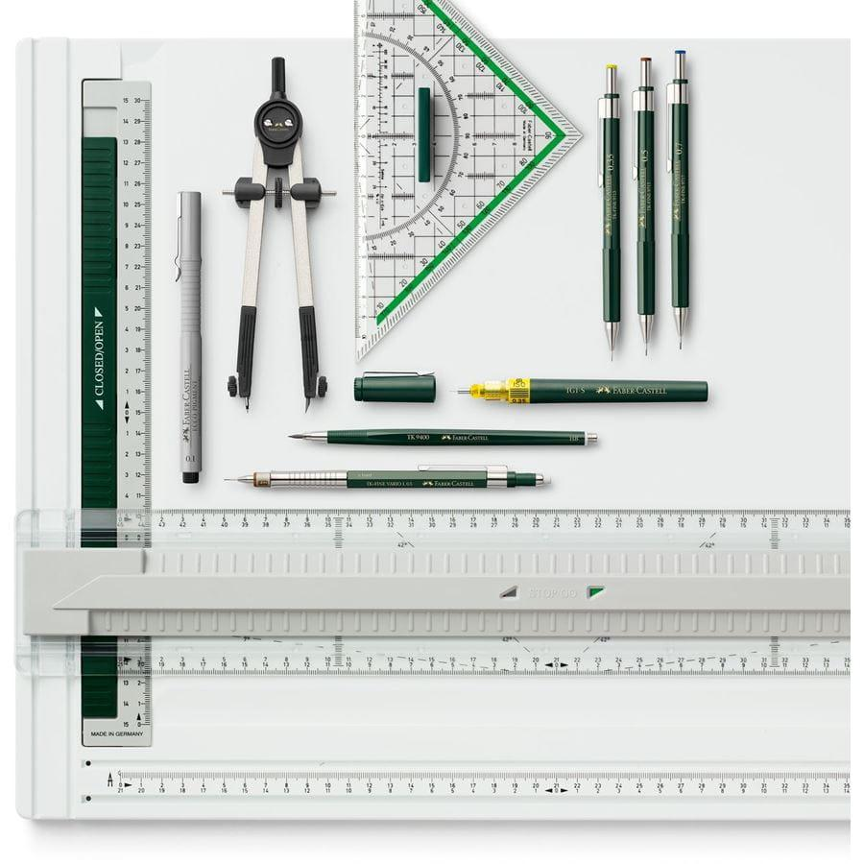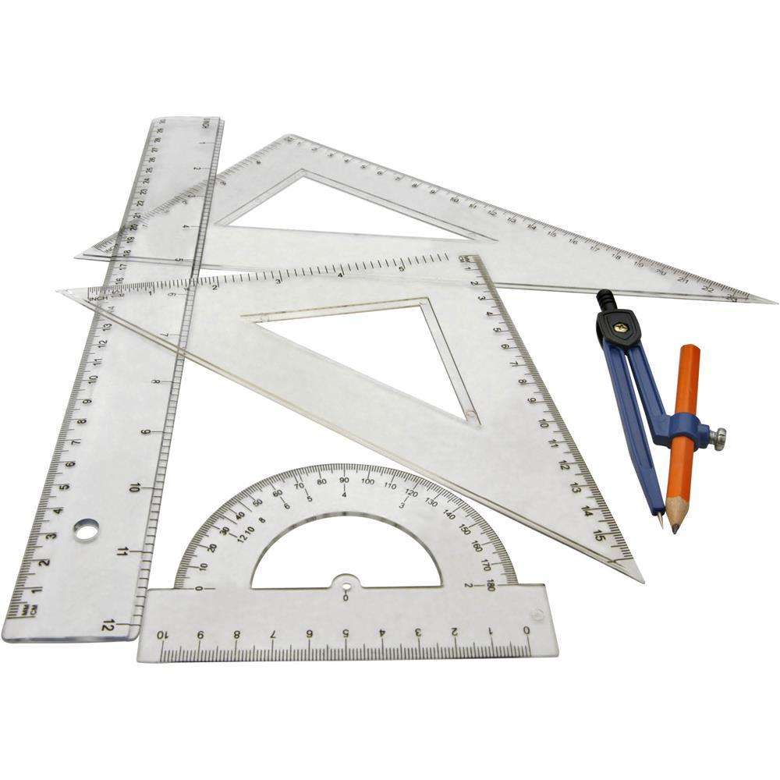
- Ruler / Straightedge: Drawing straight edges, lateral edges, and projection lines.
- Compass: Constructing a regular pentagonal base and transferring equal lengths.
- Protractor: Measuring the inclination of the cutting plane.
- Set Squares: Drawing perpendicular, vertical, and parallel construction lines.
- Pencil: Drawing outlines and construction lines.
- Eraser: Removing unnecessary construction marks after completion.

Instrument-Based Construction Procedures

Method 1: Construction Using an Oblique Cutting Plane
# Source: AI Source: Provided by: [Data Path: Persons Table -> ID Column: 1, Name_En Column: Motasem Essam] -> From: [ChatGPT] on [7/25/2026]
- Draw a regular pentagon $ABCDE$ using a compass and straightedge.
- Construct five lateral edges perpendicular to the pentagonal base.
- Connect their upper endpoints to form the upper pentagonal face of the complete prism.
- Mark five intersection points $A',B',C',D',E'$ on the lateral edges.
- Position the points at different heights according to the required cutting-plane inclination.
- Join the five points consecutively to form the pentagonal cutting section.
- Remove the upper portion of the prism conceptually, retaining the lower truncated portion.
- Darken the visible edges and use dashed lines for hidden edges.

Method 2: Construction Using Orthographic Views
# Source: AI Source: Provided by: [Data Path: Persons Table -> ID Column: 1, Name_En Column: Motasem Essam] -> From: [ChatGPT] on [7/25/2026]
- Draw the pentagonal base in the top view.
- Project the five base vertices into the front elevation.
- Construct the lateral edges and establish the prism height.
- Draw the cutting plane in the elevation.
- Mark the five intersections between the cutting plane and lateral edges.
- Project these intersection points into the corresponding views.
- Join the projected points to complete the truncated section.
- Construct the isometric view from the completed orthographic views.

Method 3: Construction Using the Surface Development
# Source: AI Source: Provided by: [Data Path: Persons Table -> ID Column: 1, Name_En Column: Motasem Essam] -> From: [ChatGPT] on [7/25/2026]
- Draw a development baseline.
- Divide it into five equal sections corresponding to the five pentagonal base edges.
- Construct five adjoining rectangular panels representing the original lateral faces.
- Transfer the measured cutting heights from the elevation onto the corresponding panel boundaries.
- Join the transferred points in sequence.
- Draw the original pentagonal base and the truncated pentagonal section in their appropriate positions.
- Mark the fold lines and the cutting boundary.
- Complete the development by distinguishing cut edges from fold edges.
The development method follows the principle of unfolding the lateral faces in sequence while transferring the cutting intersections from the projected views.

Key Points
# Source: AI Source: Provided by: [Data Path: Persons Table -> ID Column: 1, Name_En Column: Motasem Essam] -> From: [ChatGPT] on [7/25/2026]
- It originates from a pentagonal prism.
- It is classified under truncated prisms.
- Cutting planes produce new faces.
- The resulting faces may be triangular, quadrilateral, pentagonal, or other polygons, depending on the cut.
- It does not have one universal set of face, edge, and vertex counts.

Conclusion
# Source: AI Source: Provided by: [Data Path: Persons Table -> ID Column: 1, Name_En Column: Motasem Essam] -> From: [ChatGPT] on [7/25/2026]
The Truncated Pentagonal Prism is a modified pentagonal prism formed by removing one or more portions with cutting planes. Its geometric structure and mathematical properties depend on the truncation method and the position of the cuts.

